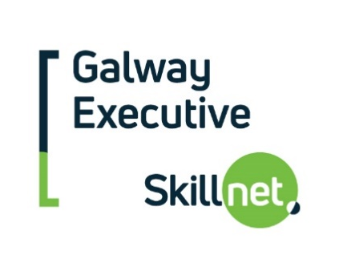
Third Level QQI Programme Support
Application (Autumn 2021)

NB: Please read the Third Level QQI Programme Support Application Guidelines before completing this form.

Company Name
Company Background
Main Contact
Email
Phone

Learner Name
Role / Job Title
Highest attainment level on the National Framework of Qualifications (NFQ)

College / Institution
Programme Title
QQI Level
Start Date
End Date
Learner Contact Days
Study / Project Assignment Days
Total Course Fees

Please outline the benefits completion of this course will bring to your company?
Please outline the benefits completion of this course will bring to the learner?
Has your company applied for or received funding from any other source for this programme?

Signed:
Date:

You must email a completed application form by 5pm Friday, August 27th to:

info@galwayexecutiveskillnet.com

A digital signature from the company main point of contact is acceptable.

Applications will be assessed and a decision communicated by mid-September.

